Deadlock in concurrency
OBJECTIVE:
Implementing multiple thread blocked resources with help of lock and deadlock conditions.
Lab Task:
Create three threads by implementing thread synchronization block through 3 locks. (Hint: Apply
un-sequenced lock to analyze deadlock and solve it through provided solution:

Code:

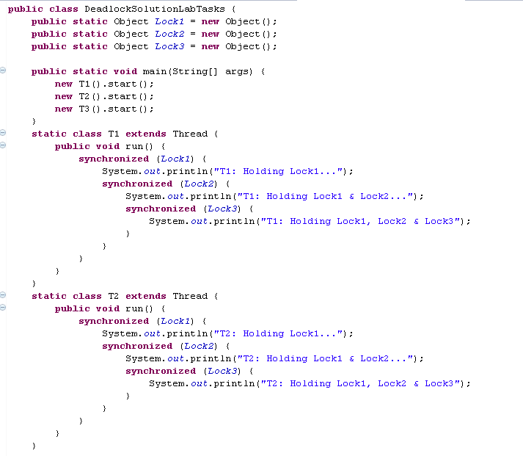
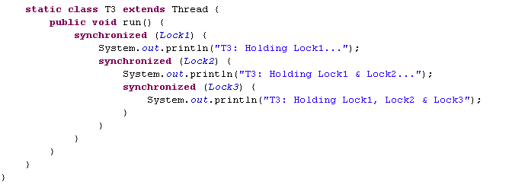
Output:
